**How To Install Window 11**



Session: 2022 – 2026

**Submitted by:**

Saqib Bin Tariq 2022-CS-195

Abdul Wahab 2022-CS-200

**Supervised by:**

Sir Numan Shafi

Department of Computer Science

**University of Engineering and Technology**

**Lahore Pakistan**

# Steps:

* Check your laptop Specifications for Win 11
* Install win11 iso file
* Insert a USB and make it bootable by rufus
* Restart laptop in which you want to install win 11
* Press Ese or F2 to select bootable USB

## Follow these Pictures:

* 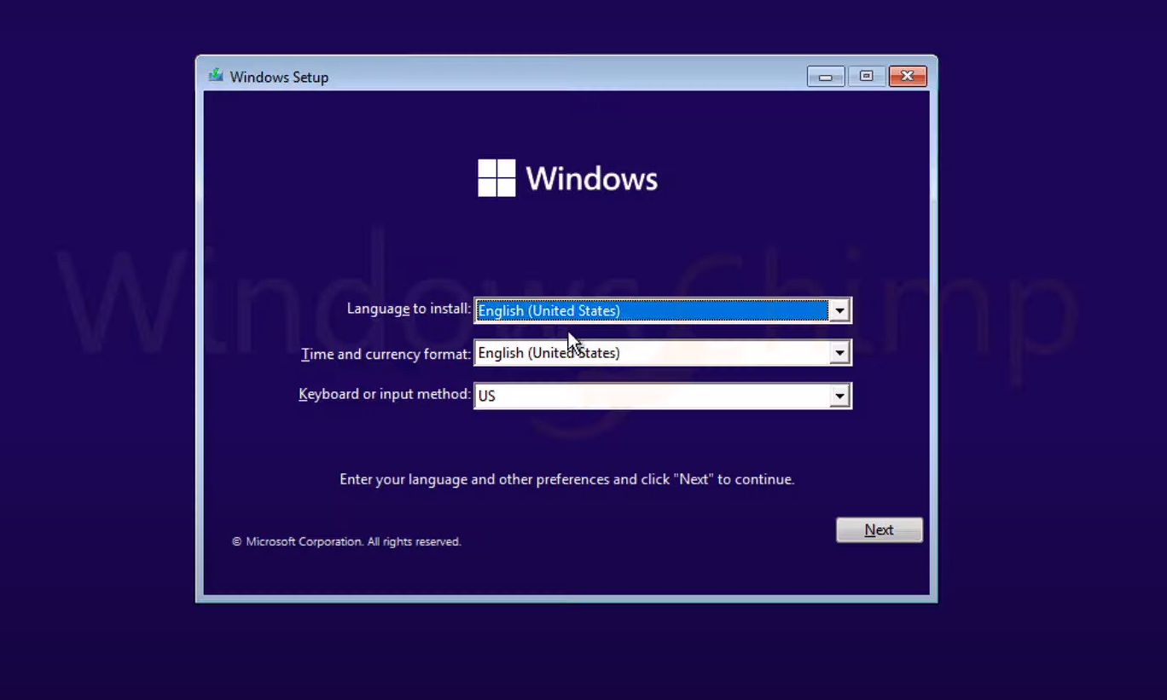Press Next

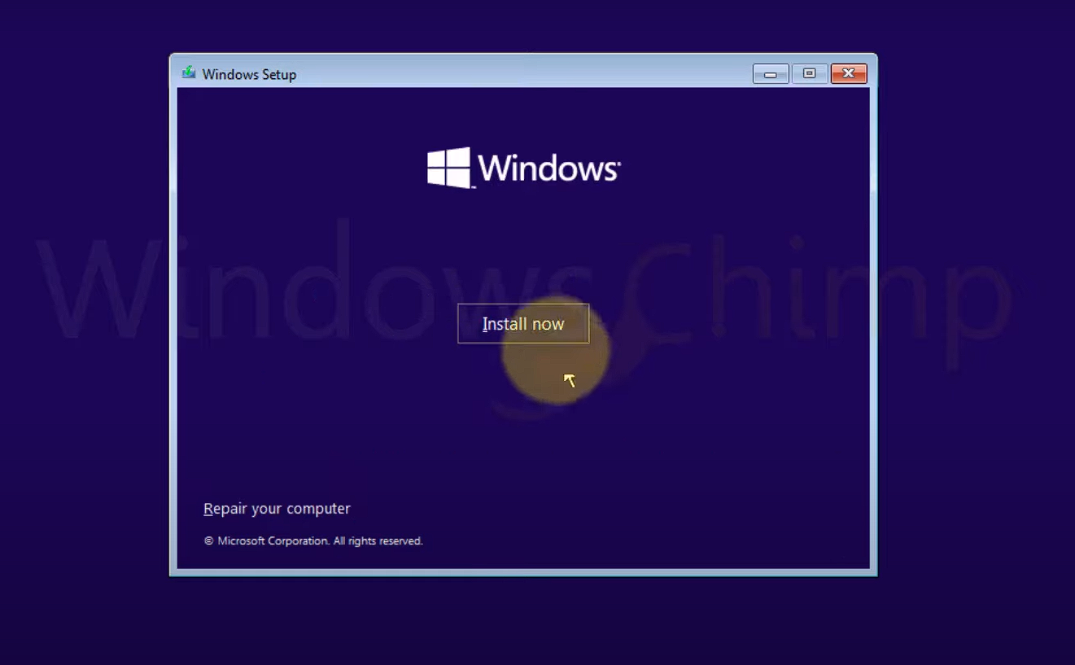



* 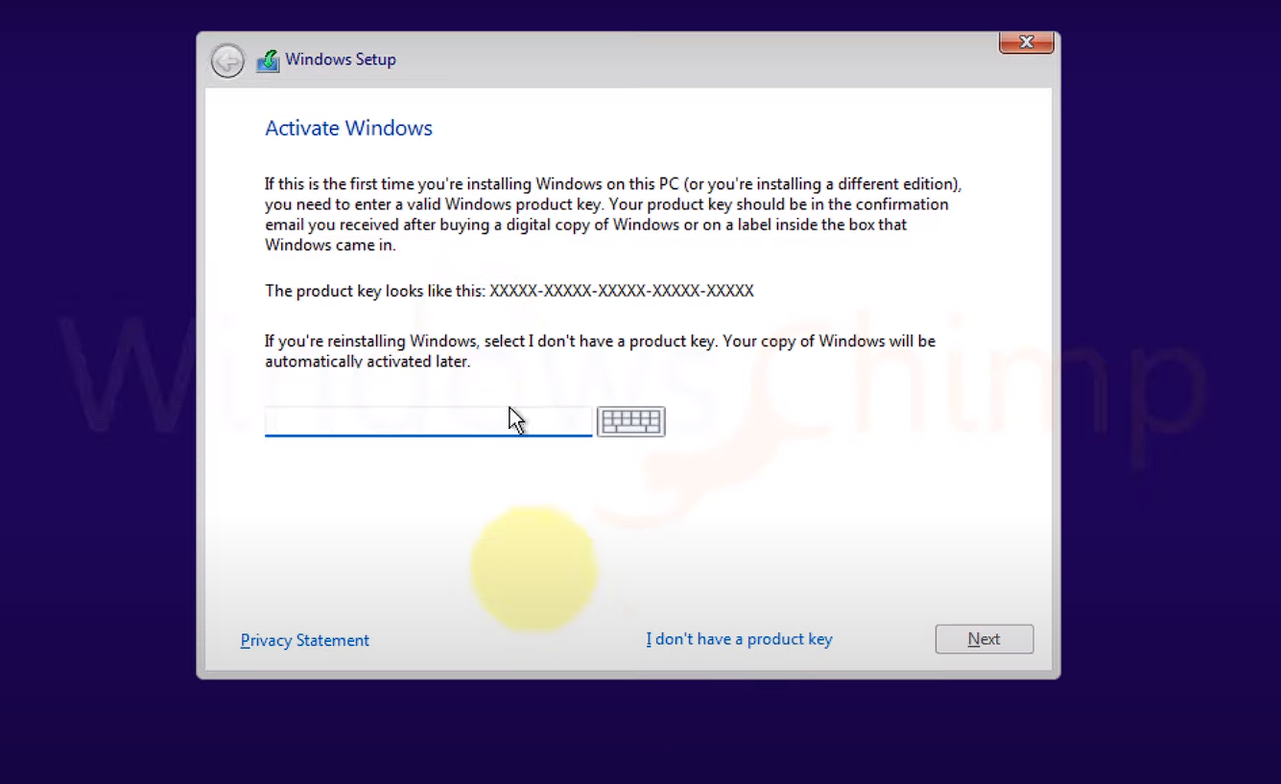Press I do not have license Key
* 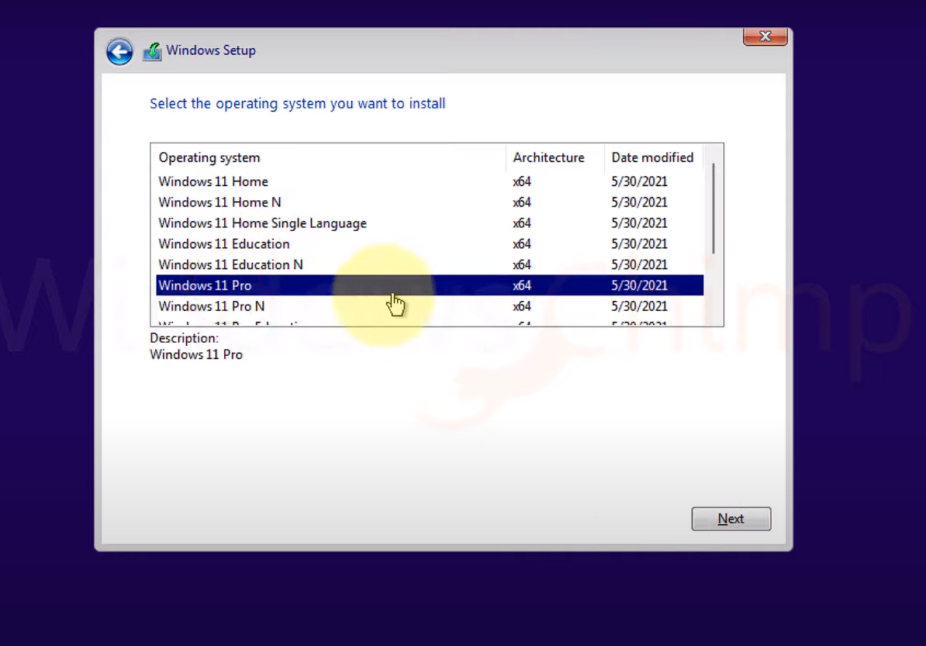Select Window Edition

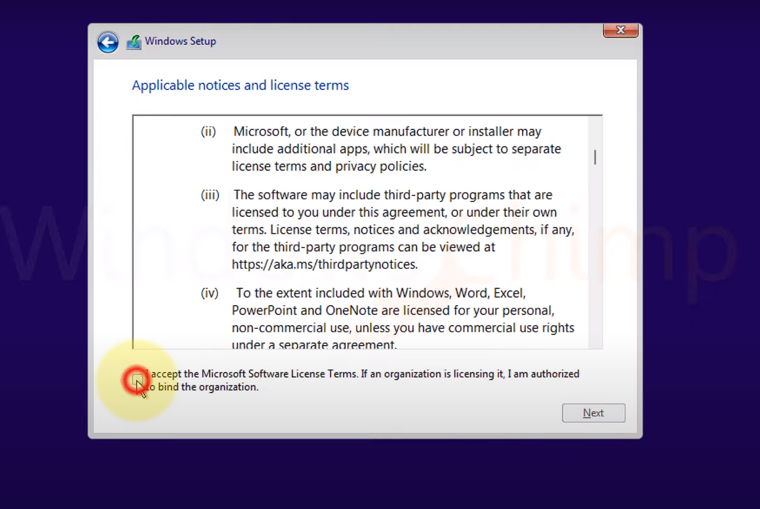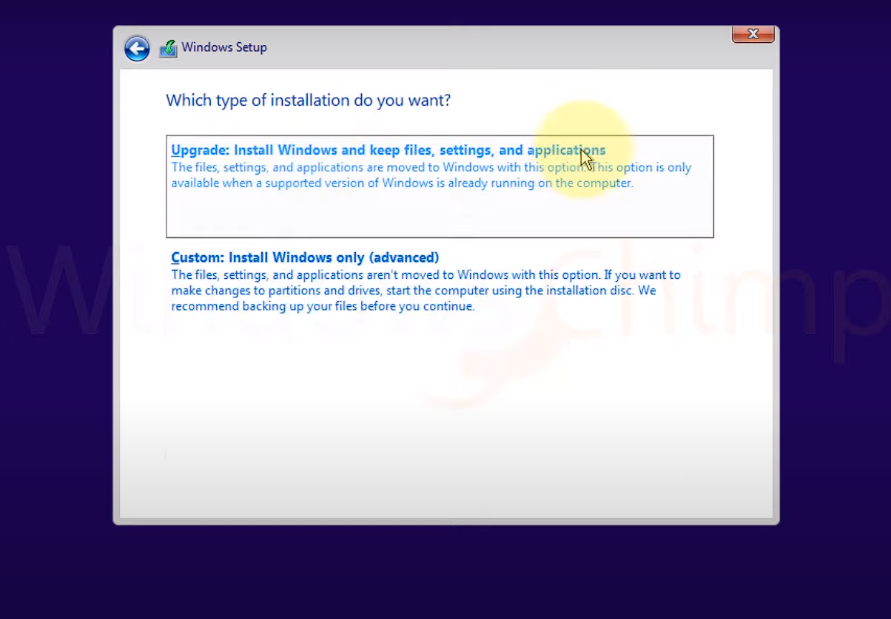

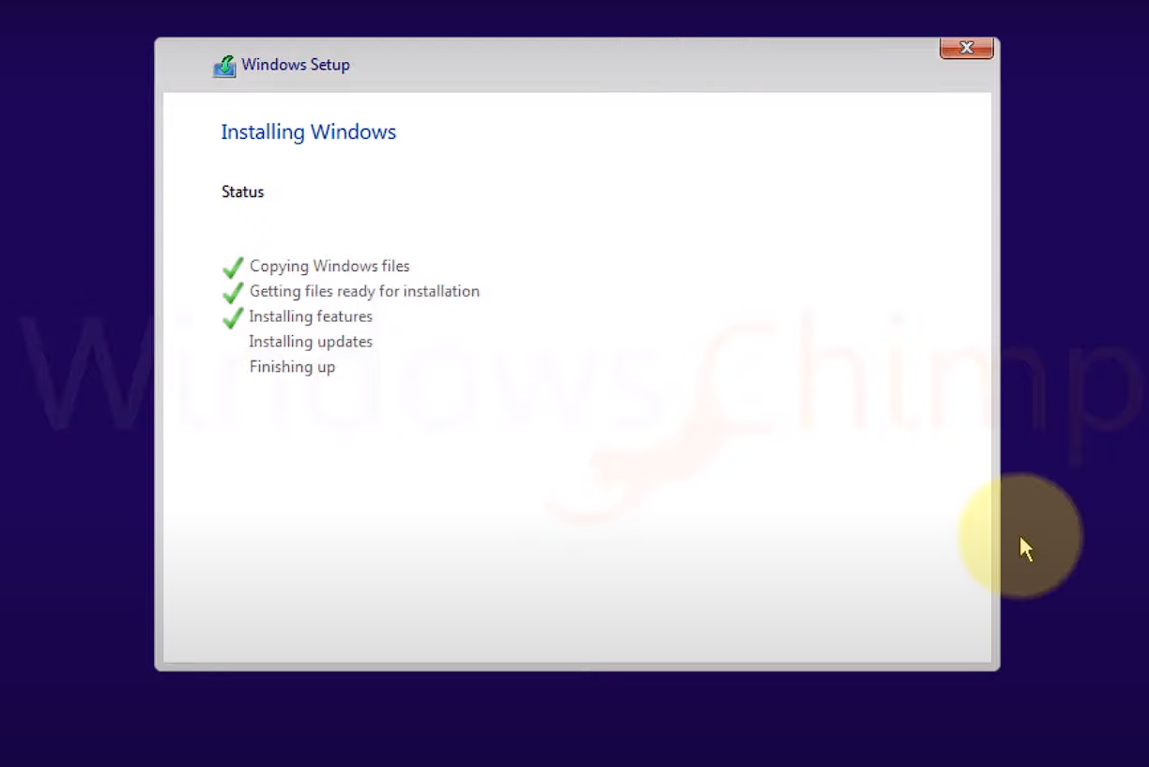

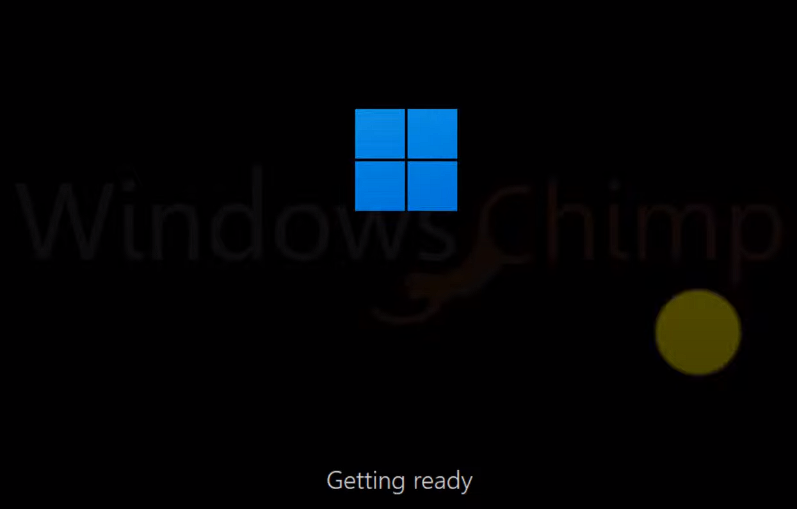

### My Laptop Specifications:

* **Dell Latitude 14 5490 Intel Core i5-8250U 8th Generation**
* 8-Logical Processors
* 4-Core
* Ram 8Gb
* SSD 256Gb
* Intel(R) UHD Graphics 620

